E-Finance Information Technology Governance Analysis Using the Domain MEA COBIT 5 Frameworks in the Regional Financial Agency of Salatiga City

Delvy Alva Pattiasina
Information System,
Kristen Satya Wacana University, Salatiga, 50715, Indonesia
682014083@student.uksw.edu

Yani Rahardja
Information System,
Kristen Satya Wacana University, Salatiga, 50715, Indonesia
yani.rahardja@uksw.edu

Melkior N.N Sitokdana*
Information System,
Kristen Satya Wacana University, Salatiga, 50715, Indonesia
melkior.sitokdana@uksw.edu
*Corresponding author

Abstract— Utilization of Information Technology (IT) is able to produce good government management. The implementation of E-Finance continues to be developed by the Regional Finance Agency "BKD" in helping people make online tax payments and management through the website. COBIT 5 as a framework that focuses on control, not execution, so that it can optimize IT utilization, as well as ensure service delivery and measure against what can be done to answer future needs. This research focuses on one of the COBIT 5 domains in it, namely Monitor, Evaluate, and Assess (MEA). By utilizing the Domain MEA COBIT 5. The results of the calculation of the maturity level of IT management at Regional Finance Agency of Salatiga City have reached level 2 in the Capability Model table, namely Managed Process with the results of the gap analysis of each process is the GAP from MEA01 of 2.19, in MEA02 with GAP owned by 2.56 and MEA03 has a GAP of 2.46. In each process, the MEA domain from MEA01, MEA02, and MEA03 has been conducted, monitored, and evaluated on IT performance with reference to organizational policies (Niemann, 2010).

Keywords—Analysis, E-finance, IT Governance, COBIT 5, MEA.

I. Introduction

Utilization of Information Technology (IT) is able to produce good governance management. Good governance is a government that serves the community quickly, accurately, transparently, and accountably. E-Government is a form of good governance, supported by the use of IT, as well as productive and efficient management. The application of E-Government within the scope of government can form an equal, mutually supportive relationship between the government in the business sector and the wider community so that government performance will also be more effective and efficient. The Regional Finance Agency "BKD" of Salatiga City was formed on December 13, 2004, which was originally a combination of the Regional Revenue Service "DIPENDA" and the Finance Section of the Salatiga City Secretariat. A change of regulation, the "DPPKAD" changed to a Regional Financial Agency "BKD" in accordance with the Salatiga City Regional Regulation "Perda" Number 9 of 2016. The budgeting module and regional financial management are the two modules that are regulated in financial administration called E-finance. E-finance itself is the result of innovation from the Regional Finance Agency "BKD" and is assisted by a third party based on existing regulations, as a form of implementing E-Government by utilizing IT, by adjusting the needs and accuracy of system use. In 2014 E-finance switched to a web display which was originally a desktop display in 2008 because using the desktop version of each stand-alone application there was a problem with the export and import process so that the incoming data was not consistent (Zolper, 2013).
The application of e-finance continues to be developed by the Regional Financial Institutions "BKD" in helping the public make payments and tax management online through the website, however, several obstacles are encountered in their delivery so that people feel confused about accessing and prefer to come to the office in person to make payments tax manually. From the existing problems, the researchers chose COBIT 5 as a framework that focuses on control, not execution, so as to optimize IT utilization, as well as ensure service delivery and measure what can be done to answer future needs.
This research focuses on one of the COBIT 5 domains in it, namely Monitor, Evaluate, and Assess (MEA). By utilizing the MEA COBIT 5 Domain The results of this research are expected to show that the use of the MEA domain COBIT 5 framework in the analysis of IT governance performance in the implementation of the system in the Salatiga City Regional Financial Board will increase the focus of IT management so as to improve strategic alignment, value delivery, management risk, and measurement of IT performance .
Previous research related to IT Governance using the MEA domain COBIT 5 framework has previously been conducted, here are some studies that were selected as a reference for compiling this research.
Research related to IT Governance uses the COBIT 5 framework with the title "Performance Evaluation of Port Operational Management Information Systems Using COBIT 5 at PT. Pelabuhan Indonesia II (Persero) Cabang Panjang, Lampung ". Research conducted to evaluate the performance of "SIMOPEL" (Port Operational Management Information System), in this study used COBIT 5 domain MEA. The purpose of this research is to ensure the quality of IT governance performance in the application of "SIMOPEL". The results of this study indicate that the MEA domain at COBIT 5 gets results at the Established level because development needs are still being carried out internally to optimize service needs. Therefore, "SIMOPEL" PT. Pelabuhan Indonesia II (Persero) Cabang Panjang needs various adjustments and additional facilities to improve service quality. The objectives of "SIMOPEL" have been identified to allow re-evaluation of the performance of information systems (Yola T Victoria, et al 2018).
The research entitled "Implementation of the Domain Focus 5 (MEA) Cobit framework in the Evaluation of Information Technology Governance at the Department of Communication, Informatics, and Statistics, Riau Province". This study uses COBIT 5 domain MEA. The research was conducted to determine the target use of information technology at the Office of Information Communication and Statistics, whether the use of information technology has been running well so that monitoring, evaluation, and assessment are required. The results of the study show the maturity level of information technology governance at the Office of Information Communication and Statistics in the field of e-government services using the MEA02 domain reaches the level of 3.92, namely the achievement of each process has not been fulfilled as a whole and has not achieved the objectives expected by the Informatics and Statistics Communication Office Riau Province (Hadi Asnal, et al 2020).
The research entitled "Measurement of the Maturity Level of IT Governance in Implementing Personnel Management Information System Using the MEA Domain COBIT 5 framework In Regional Personnel, Education and Training Agency". Journal of Information Systems and Informatics. Research conducted to assess the quality of information technology governance in the application of the Personnel Management Information System “SIMPEG”. This study uses COBIT 5 domain MEA to observe, evaluate, and assess IT governance in the implementation of “SIMPEG” in “BKDIKLATDA”. The results of the study show that the maturity level in MEA01 reaches 3.70 with the process capability model achieved at level 4 predictable process with a GAP of 1.3. In MEA02 (Monitor, Evaluate, and Assess the System of Internal Control) with an average maturity level of 3.36 with the process capability model achieved at level 3 the established process with a GAP of 1.64. In MEA03 (Monitor, Evaluate and Assess Compliance with External Requirements) with an average maturity level of 3.55 with the process capability model achieved at level 4 predictable process with GAP at 1.45 (Stanny D Rehatta, et al. 2019).
The research entitled "Performance Measurement of Financial Management Information System Office of Kemranjen District, Banyumas Regency Using COBIT 5.0 framework". In the MEA Domain (Monitor, Evaluate, And Assess). This research discusses the measurement of the performance of information systems at the Office of the Kemranjen District, Banyumas Regency in order to improve the performance of the existing system. The results of this study indicate that the performance measurement using the MEA domain COBIT 5 on the system used gets an average capability level value of 2 or managed process (Alizar Mustofa, et al. 2017).

II. Literature Review

The following describes the research object, methods and stages of the research conducted;

- Information Technology Governance
Information Technology Governance (IT Governance) is the organizational capacity as the responsibility of the board of directors, executive management, and IT management to control the formulation and implementation of IT strategies to ensure the alignment of IT resources with the organization's business (Grembergen, 2012). Governance analysis is a review of the implementation of new regulations in running business processes by utilizing information systems to improve performance and services provided by the organization/company to the public. In its application, there are several problems encountered, the results of the analysis are in the form of recommendations that determine the best way to deal with existing problems.

- COBIT 5
COBIT stands for Control Objectives for Information and related Technology. COBIT 5 is an important business framework in terms of helping IT corporate governance and management. COBIT provides principles, practices, and acceptable models to help the company achieve its goals so as to create optimal value from IT to maintain a balance between realizing benefits and optimizing the level of risk in the use of resources so as to increase the value of a company. COBIT 5 discusses the business and IT functional areas of a company and considers the interests associated with IT internally and externally for stakeholders. COBIT 5 is useful for companies and government agencies (Obi, 2010). COBIT 5 has 37 processes in 5 domains which are divided into the Governance and Management domain as shown in Picture 1.
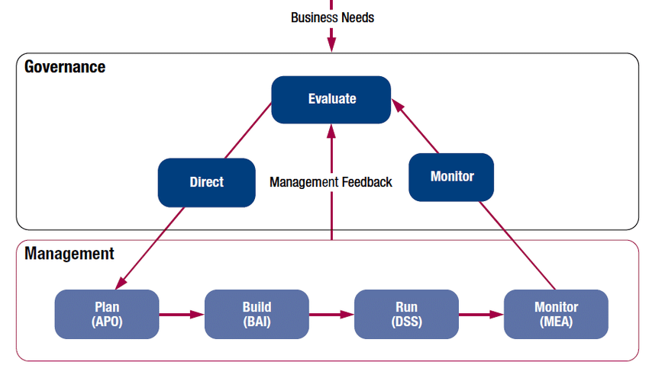
Picture 1. Governance and Management Key Areas (Source: ISACA 2012)

COBIT 5 is the latest version of the ISACA directive on corporate IT governance and process management, dividing it into two main domains, namely (ISACA, 2012):
- Governance (Governance) is responsible for monitoring directly evaluate direct and monitor (EDM) domain. This process is assigned responsibility for evaluating, directing, and monitoring the use of IT.
- Evaluate, Direct and Monitor (EDM)
This domain defines the governance framework, builds responsibility in terms of value (eg, investment criteria), risk factors and resources (eg, optimization of resources), and maintains transparency of IT to stakeholders.
- Management contains four domains in accordance with responsibilities such as process (PBRM), planning (planning), the development process (building), the process that is currently running (running), and processes.
- Monitor, Evaluate and Assess (MEA)
MEA, including the process responsible for the assessment of process performance and conformity, evaluation of internal control adequacy, and monitoring of regulatory compliance.
- Align, Plan and Organise (APO)
Associated with IT strategy and tactics or strategy, enterprise architecture, innovation, and portfolio management. Other important processes address budget and cost management, human resources, relationships, service agreements, suppliers, quality, risk, and security.
- Build, Acquire and Implement (BAI)
Providing solutions for realizing IT strategies that are developed or implemented into business processes, managing and controlling changes related to business processes, and carrying out activities such as tracking, reporting, and documentation to ensure the value and quality of company deliverables.
- Deliver, Service and Support (DSS)
Services required to fulfill strategic and tactical plans. The DSS domain includes processes for managing operations, service requests, and incidents, as well as problem management, continuity, security and business process control.

- Capability Model
In this research, the Capability Model is used, to measure the level of maturity and capability of the existing system in “BKD” of Salatiga City. The following is the level of capability, can be seen in Table 1 (ISACA, 2012).

Table 1. Capability Levels
(Source: ISACA 2012)
Level | Maturity Criteria
0 Incomplete Process | Incomplete process
1 Perfomed Process | Process executed (one attribute); That process  implemented successfully achieve its objectives
2 Managed Process | Regular process (two attributes); The processes that have been carried out as above have been implemented in a more orderly manner (planned, monitored and adjusted)
3 Established Process | Fixed process (two attributes); The above process has been implemented using certain processes that have been determined, which is able to achieve the expected outcome
4 Predictable Process | Predictable process (two attributes); The above process has been carried out within the specified limits to achieve the expected outcome
5 Optimizing Process | Optimization process (two attributes); The above process is continuously improved to meet current and future business goals

III. Research Methods

- Research Methods
The approach used in this study is a mixed-method. The mixed-method is a research approach that combines or connects qualitative and quantitative research methods, it will be useful if quantitative or qualitative methods alone are not accurate enough to be used to understand research problems Cresswell, 2009 (Sugiyono, 2012).

- Research Stages
The results of data collection are based on real field conditions with direct information from informants, with 6 stages of research on Picture 2.
START
PRELIMINARY STUDIES
IDENTIFICATION OF PROBLEMS
DATA ANALYSIS
Monitor, Evaluate, and Asses (MEA)
RECOMMENDATION
FINISH
DATA COLLECTION
Interview & Questionnaire

Picture 2. Research Stages

- First Stage
Preliminary Study, the initial stage carried out is a preliminary study by studying and understanding Information Technology management and governance and an understanding of the COBIT 5 framework which is used as a research framework for observations on the information system profile “E-finance”
- Second Stage
Data collection, this stage of data collection through interviews and questionnaires. Interviews were conducted to determine the profile of the organization, business processes, and findings of problems, as well as governance conditions in IT application. The questionnaire was given in order to obtain data on the maturity level of IT governance that is applied to the Regional Financial Board
- Third Stages
Data analysis, at this stage an analysis of the results of the data collection has been carried out. Data analysis begins with aligning organizational goals with four perspectives on the balanced scorecard. The results of the alignment are then identified as the selected enterprise goals. Next, we map the enterprise goals with IT-Related goals. Then mapping the selected IT-Related goals against the COBIT 5 process to determine the domains to be used. However, the research only focuses on the MEA domain
- Fourth Stages
Recommendations, this stage is in the form of recommendations given in order to overcome problem findings when implementing E-finance. In the future, own recommendations can assist organizations in improving the performance and services provided.

- Research Respondents
RACI stands for: Responsible, Accountable, Consulted, and Informed. COBIT 5 explains that the RACI chart is a matrix for all activities or authorization decisions that must be taken in an organization associated with all parties or positions involved. The following is a table 2 RACI chart showing several respondents (Rehatta, Stanny D, 2019).

Table 2. Mapping of the RACI Chart of Salatiga City Regional Financial Agency
RACI | Respondent Name | Position
Responsible | Mr. Aditya Yoga. P | Sub Division Staff of Service, Data & Information Management
 | Mr. Hanung Pujohastono
Accountable | Mr. Fajar Agus Widigdo | Head of Sub Division of Services, Data & Information Management
Consulted | Mr. Karyanto | Head of Civil Service
Informed | Mother. Yeni Sri Sulistyani | Sub Division Staff of Service, Data & Information Management

IV. Results and Discussion

- Process Identification of the COBIT 5 Domain
BSC Dimension |  | Enterprise Goals Selected | Purpose of Information Systems  E - Finance
Financial | 3 | Managed business risk (safeguarding of assets) | Data and asset security becomes integrity within and between the Salatiga City Government Organizations
 | 4 | Compliance with external laws and regulations | The development and implementation of IS / IT refers to regulations  Ministry of Home Affairs for financial management.
 | 5 | Financial transparency | Increase the accountability and transparency of data that is adjusted to data in the field, based on routine checks.
Customer | 6 | Customer-oriented service culture | Improve IS-oriented public services and its application in order to align business processes to achieve organizational goals.
 | 8 | Agile response to a chaging business environment | Implementing SI as a means of supporting business processes in terms of public services.
Internal | 11 | Optimization of business process functionallity | Optimizing the system effectively, efficiently and accountably, to increase the degree of fiscal autonomy towards regional financial independence.
Learning & Growth | 17 | Product and business innovation culture | Developing SI every year with innovations that adjust to internal and external needs that refer to regulations, in carrying out business processes.
In e-finance is one of the objectives of the Regional Government of Salatiga City in implementing e-Government based on the rules mandated in Presidential Instruction No.3 of 2003 concerning e-Government Development Strategies to support good governance (including transparency and public accountability) and accelerate the democratic process. Then, to achieve transparency and public accountability, it is also stated in Law Number 14 of 2008 concerning the Openness of Public Information. e-government is one of the priority sectors for Indonesian Broadband Development in accordance with Presidential Regulation Number 96 of 2014 concerning the Indonesian Broadband Plan 2014-2019. Article 7 states the priority of Indonesia's broadband development in five sectors, such as e-Government, e-Health, e-Education, e-Logistics, and e-Procurement. So it is clear that e-government has become an important thing to implement in various fields of government. As for one of the benefits of e-government, "The use of electronics is to cut the bureaucracy, if it is not the same, it is electronic," said Mrs. Risma during the E-ID card inspection with Aiman, Source. KompasTV, 2016. After analyzing the data on the maturity level of IT governance conducted by interview and questionnaire, then aligned the vision, mission of “BKD” Salatiga city with the COBIT 5 Enterprise Goals in identifying priority stakeholder needs. On the table. 3 is explained by analysis that refers to the Balanced Scorecard which is grouped into 17 company goals with 4 aspects, namely Financial, Customer, Internal, and finally Learning & Growth.

Table 3. Identification of selected COBIT 5 Enterprise Goals with the aim of E-finance

After identifying the selected Enterprise Goals for E-finance purposes, then mapping the Enterprise Goals against IT-Related Goals by selecting P (Primary key) because of the linkage with the identified Enterprise Goals. Mapping results are described in table 4.

Table 4. Description of the selected IT-Related Goals Mapping Results
Code | IT-Related Goals
ITRG01 | Alignment of IT and business strategy
ITRG02 | IT compliance and support for business compliance with external law and regulations
ITRG04 | Managed IT-related business risk
ITRG06 | Transparency of IT costs, benefits and risk
ITRG07 | Delivery of IT services in line with business requirements
ITRG08 | Adequate use of applications, information and technology solutions
ITRG09 | IT agility
ITRG10 | Security of information, processing infrastructure and applications
ITRG12 | Enablement and support of business processes by intergrating applications and technology into business processes
ITRG16 | Competent and motivated business and IT personnel
ITRG17 | Knowledge, expertise and initiatives for business innovation

After the results of the mapping of Enterprise Goals to IT-Related Goals, then the selected IT-Related Goals are mapped into the COBIT 5 Process. Mapping results can be seen in Picture 3 and Table 5, with the Primary key (P) as the benchmark :

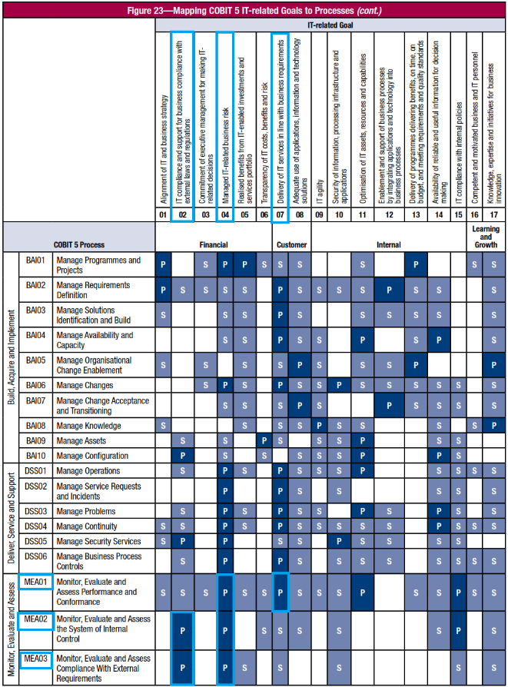
Picture 3. Mapping IT-Related Goals into COBIT 5 Processes (Source. ISACA, 2012)

Table 5. Description of the Mapping Results of IT-Related Goals into the COBIT 5 Process

IT-Related Goals | COBIT 5 Process | Description
ITRG02 | MEA02, MEA03 | MEA01 Monitor, Evaluate  and Assess  Performance  and Conformance.
ITRG04 | MEA01, MEA02, MEA03 | MEA02 Monitor, Evaluate and  Assess The System of  Internal Control.
ITRG07 | MEA01 | MEA03 Monitor, Evaluate and  Assess Compliance  with External  Requirements.

This research is managed on the existing IT governance at “BKD” of Salatiga City so that the chosen domain is MEA. Based on the results of the questionnaire that has been sent to the respondents who are directly in the Information System, the expectation data obtained from interviews or questionnaires that the average level of capability is at level 5 Optimization Process. The results of the MEA domain 5 COBIT maturity level are as Table 6.

Table 6. MEA01 Maturity level results
Activity Process
MEA01 Supervision, evaluation and performance assessment of technology processes
information on the Regional Finance Agency of the City of Salatiga against
policies that have been set and provide that report
systematic and timely to the Head of Service as
SKPD leader.
Maturity Level based on current condition: 2.81

Table 6 shows, illustrates the maturity level for MEA01 at level 3 Established Process. Monitoring and evaluation of the performance of existing information system processes have gone through planning and refers to certain rules to achieve the expected goals. However, the submission of the report was not in accordance with the specified time target. Due to the lack of IT expert staff due to job rotation or often called employee mutations that take a lot of time for training, as well as learning for new employees and the risk of reduced work productivity due to overlapping work on existing staff.

Table 7. MEA02 Maturity Level Results
Activity Process
MEA02 Supervision, evaluation and assessment of control systems
internal, including in planning, organizing and maintaining
standardization for internal control and assurance assessments
activity process, in this case providing a training program
regarding the use of information and communication technology
to system users.
Maturity Level based on current condition: 2.44

Established Process, in Table 7 MEA02 is at level 2, namely Managed Process. In this phase, the process is carried out and monitored in a more orderly manner. However, based on the results of the interviews conducted, it shows that the standard operating procedures “SOP” are not listed in the operation and management of existing information systems. As well as in terms of optimizing IT risks, there are no clear rules in handling problems only by case. In addition, in the management and development of e-finance, the system has been attacked by malware, as disclosed by the person in charge of the Sub Division of Services, Data Management & Information, Bpk. Fajar Agus Widigdo as follows :

“..There is a service that runs from servers for bitcoin mining, and how to handle it by looking at forums on the internet to solve this problem, so, for now, it's safe ”.

Even though the SOP has not been included to make work flow better and become a guide for new employees in managing existing information systems, data backup is always done every day with a schedule determined by the IT staff to reduce the risk of invalid data.

Table 8. MEA03 Maturity Level Results
Activity Process
MEA03 Supervision, evaluation and assessment of control systems
external, namely identifying and monitoring change
in policies, regulations and other provisions that must be
filled with information technology on an ongoing basis.

Maturity Level based on current condition: 2.54

In Table 8, the MEA03 domain maturity level is at level 2 Managed Process. In this phase, the process is carried out and monitored in a more orderly manner. Based on the application and development of e-finance from “BKD” of Salatiga City, which is in accordance with the needs of business processes, it basically refers to regulations from the center. As expressed by Bpk. Fajar is as follows :

“There are systems here that are made by themselves but not many, those that are made by themselves are used for the management of BPHTB “SIPBPHTB”. Meanwhile, other applications use third parties. So all systems that are built here are basically regulations from the center, there is already a sponsor for financial management, the standards follow the regulations from the center”.

This shows that the application and development of e-finance from the results of evaluation and assessment to match the external and internal needs of “BKD” Salatiga City has been adjusted to the regulations from the center in financial management.

- Capability Analysis and GAP
From the decomposition of the maturity level of each AEC process, an analysis of the gap is carried out to determine the GAP between the current real conditions and the expected conditions. Picture 4 and Table 9 show, it can be calculated with Reality minus Expectations.

Picture 4. Graph of level capability identification and GAP

Table 9. Results of the Calculation of Capability Level
Activity | Maturity Level | Target | GAP
MEA01 | 2.81 | 5.00 | 2.19
MEA02 | 2.44 | 5.00 | 2.56
MEA03 | 2.54 | 5.00 | 2.46

Furthermore, from the results of the calculation of the capability of each AEC process that has been carried out, to determine the current condition of IT governance at “BKD” of Salatiga City, the following formula is used (1)

$index=\frac{\sum{questionnaire answer}}{questionnaire answer}$
$index=\frac{\sum{MEA01+\sum{MEA02+\sum{MEA03}}}}{Domain Process}$ (1)
$index=\frac{2,81+2,44+2,54}{5}=1,5$
The current condition of IT management at BKD of Salatiga City is at capability level 1.5, namely managed process, which means that currently the process has been run, managed, and monitored in a more orderly manner from internal and external parts. Responsive in evaluations in order to develop information systems according to business process needs by referring to existing regulations and policies.

Conclusion

Based on the results of the calculation of the maturity level carried out at “BKD” of Salatiga City, it can be concluded that the average maturity level of IT governance at “BKD” of Salatiga City has reached level 2 in the Capability Model table, namely Managed Process with the results of the gap analysis of each process is the GAP gap of MEA01 is 2.19, in MEA02 it has a GAP of 2.56 and MEA03 has a GAP of 2.46. In each process, the MEA domain from MEA01, MEA02, and MEA03 has been carried out, monitored, and evaluated on IT performance by referring to organizational policies. Because IT governance has not been implemented properly, it can be seen from the absence of SOPs in regulating workflow on e-finance and the slow management of human resources related to e-finance management

References

Asnal, Hadi. Prilly M Gita. (2020). Implementasi Framework COBIT 5 Fokus Domain (MEA) dalam Evaluasi Tata Kelola Teknologi Informasi Pada Dinas Komunikasi Informatika dan Statistik Provinsi Riau. Jurnal Teknologi Terpadu Vol. 8 No. 1.
ISACA, (2012). COBIT® 5 Implementation. Rolling Meadows: ISACA.
ISACA. (2012). COBIT ® 5. A Bussiness Framework for the Governance and Management of Enterprise IT. USA: ISACA.
Mustofa, Alizar. Sitaresmi Wahyu Handani. (2017). Pengukuran Kinerja Sistem Informasi Tata Kelola Keuangan Kantor Kecamatan Kemranjen Kabupaten Banyumas Menggunakan Framework Cobit 5.0 Pada Domain Mea (Monitor, Evaluate, And Assess). Jurnal Pro Bisnis Vol. 10 No. 2.
Niemann, M., Siebenhaar, M., Eckert, J., & Steinmetz, R. (2010). Process model analysis using related cluster pairs. In International Conference on Business Process Management (pp. 547-558). Springer, Berlin, Heidelberg.
Obi, T. (Ed.). (2010). The innovative CIO and e-Participation in e-Government initiatives (Vol. 3). IOS Press.
Rehatta, Stanny D. Augie D Manuputty. (2019). Measurement of the Maturity Level of IT Governance in Implementing Personnel Management Information System Using the MEA Domain COBIT 5 Framework in Regional Personnel, Education and Training Agency. Journal of Information System and Informatics Vol.1 No.2.
Sugiyono. 2012. Metode Penelitian Kuantitatif, Kualitatif, Dan Kombinasi (Mixed Methods). Bandung: Alfabeta.
Van Grembergen, W. (2012). Introduction to the minitrack "IT governance and its mechanisms" HICSS 2003.
Yola V. Tagatari. Yani Rahardja dkk. (2018). Evaluasi Kinerja Sistem Informasi Manajemen Operasional Pelabuhan Menggunakan COBIT 5 pada PT. Pelabuhan Indonesia II (Persero) Cabang Panjang Lampung. Salatiga: Universitas Kristen Satya Wacana.
Zolper, K., Beimborn, D., & Weitzel, T. (2013). When the river leaves its bed: analyzing deviations between planned and actual interaction structures in IT change processes. Journal of Information Technology, 28(4), 333-353.

